
Sukkur IBA University
Department of Computer Science
Compiler Construction Lab

Lab # 03: Finite Automata: DFA Design, NFA-to-DFA Conversion, and Automata Simulation in C
Instructor: Muhammad Ismail Qureshi
Submission Profile
Name: Submission date (dd/mm/yy):
Marks obtained: Receiving authority name and signature:
Comments:
________________________________________________________________________________
Instructor Signature

Note: Submit this lab hand-out on LMS/e-learning before the next lab with attached solved activities and exercises

Lab Learning Objectives:
Upon successful completion of this experiment, the student will be able to:
- Formally define and design Deterministic Finite Automata (DFA) and Non-Deterministic Finite Automata (NFA) for regular languages.
- Translate theoretical state diagrams into structured tabular representations suitable for programming.
- Implement programmatic simulation of finite automata in C to accept or reject lexical streams.
- Understand the principles of subset construction for converting NFA states into DFA states.
Lab Hardware and Software Required:
• GCC Compiler (MinGW-w64 for Windows, native GCC on Linux/macOS)
• Visual Studio Code / C IDE
• Terminal / Command Line Interface
• PC
Background Theory:

1. Formal Definition of Finite Automata
A Finite Automaton is a 5-tuple $\left(Q,Σ,δ,q_{0},F\right)$, where:
- $Q$: A finite set of states.
- $Σ$: A finite input alphabet.
- $δ$: A transition function mapping $Q×Σ→Q$ (for DFA) or $Q×\left(Σ∪\left\{ϵ\right\}\right)→P\left(Q\right)$ (for NFA).
- $q_{0}$: The start state ($q_{0}∈Q$).
- $F$: The set of accept/final states ($F⊆Q$).

2. DFA vs. NFA
- DFA (Deterministic Finite Automaton): For every state, there is exactly one transition per input symbol, and no $ϵ$ (epsilon) transitions are allowed.
- NFA (Non-Deterministic Finite Automaton): A state can have zero, one, or multiple transitions for the same input symbol, and $ϵ$ transitions are permitted. While easier to design for complex regex patterns, compilers ultimately convert NFAs into DFAs for deterministic execution speed.
Lab Examples:

Example 1: Simulating a DFA in C
The following C program simulates a DFA that recognizes binary strings ending with the character '1' (Alphabet $Σ=\left\{0,1\right\}$).
- States: $Q=\left\{q_{0},q_{1}\right\}$
- Start State: $q_{0}$
- Accept State: $F=\left\{q_{1}\right\}$
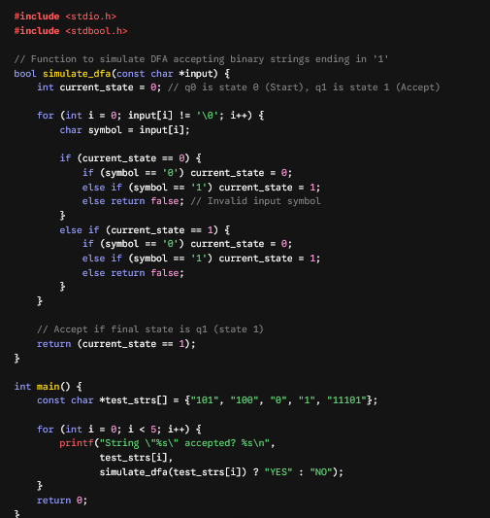

Lab Activities:

Activity 1: Transition Table Matrix Implementation
In lexical scanners, transition functions are often encoded as 2D lookup tables to maximize performance.
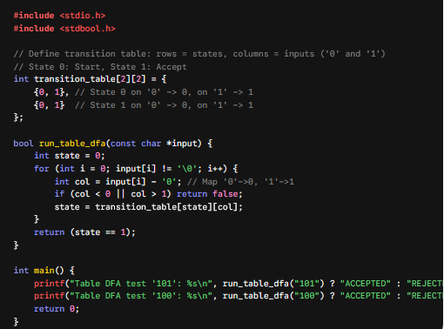
Lab Exercises:

Exercise 1: Multi-State DFA Validator
Design and implement a DFA in C that accepts strings over alphabet $Σ=\left\{a,b\right\}$ containing an even number of 'a's. Write the transition simulation code and test it with strings like "abba", "aab", and "bbaab".

Exercise 2: NFA State Tracking Simulator
Implement a C program that simulates an NFA transition structure using arrays to track multiple active states simultaneously during input processing.

Exercise 3: NFA to DFA Conversion Table Documentation
Document the subset construction steps for an NFA recognizing the regular expression (a|b)*abb. Provide the resulting DFA transition table and state mapping in your lab report.

